Agenda- to create page list and add sample 5 records to it

First Create Data Type and add the required fields and configure the source

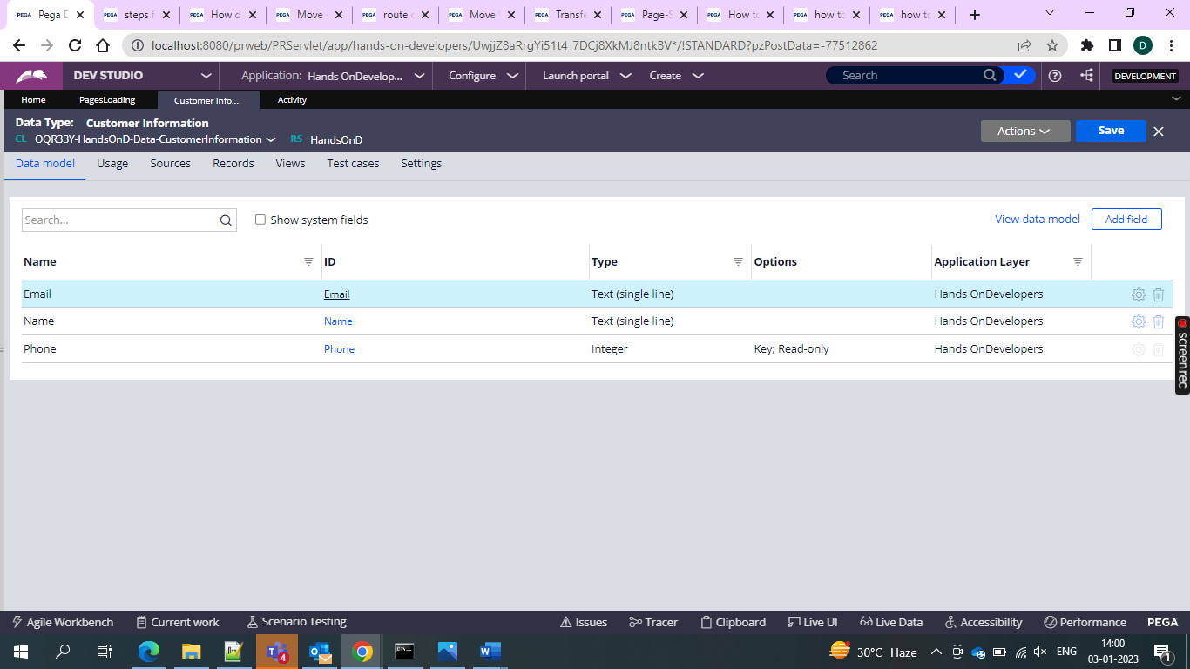

And then write activity as below

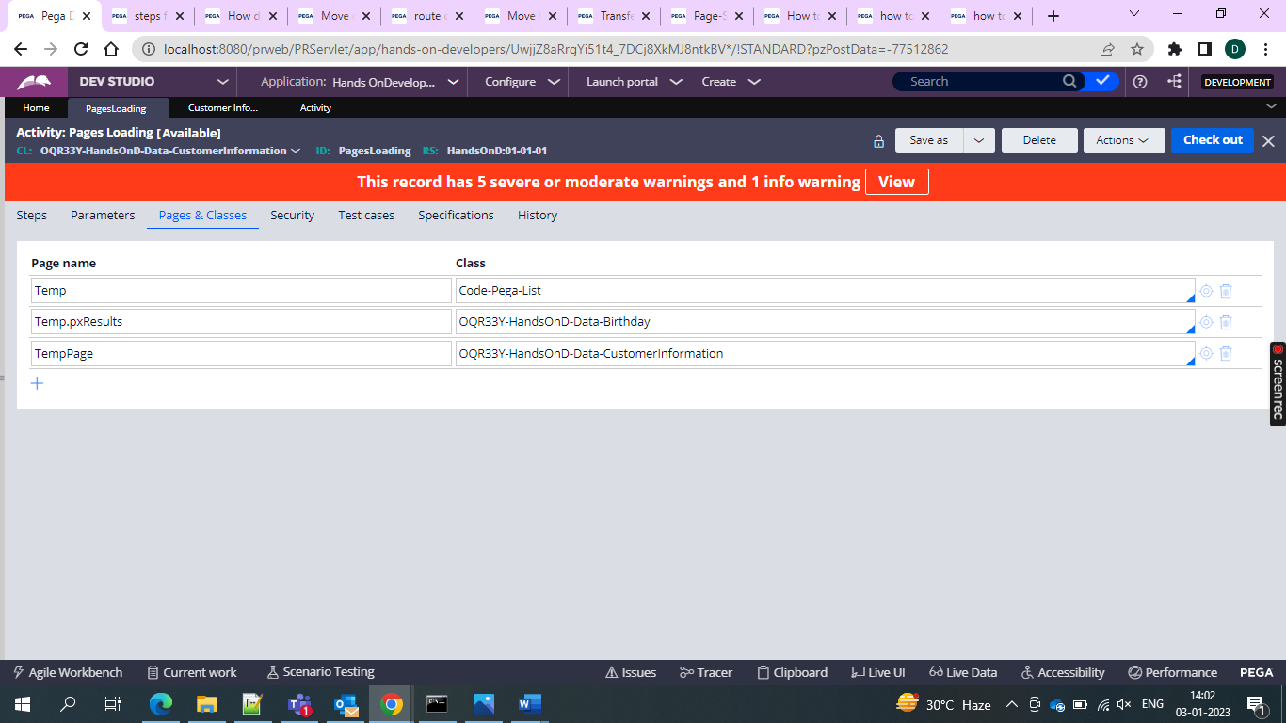

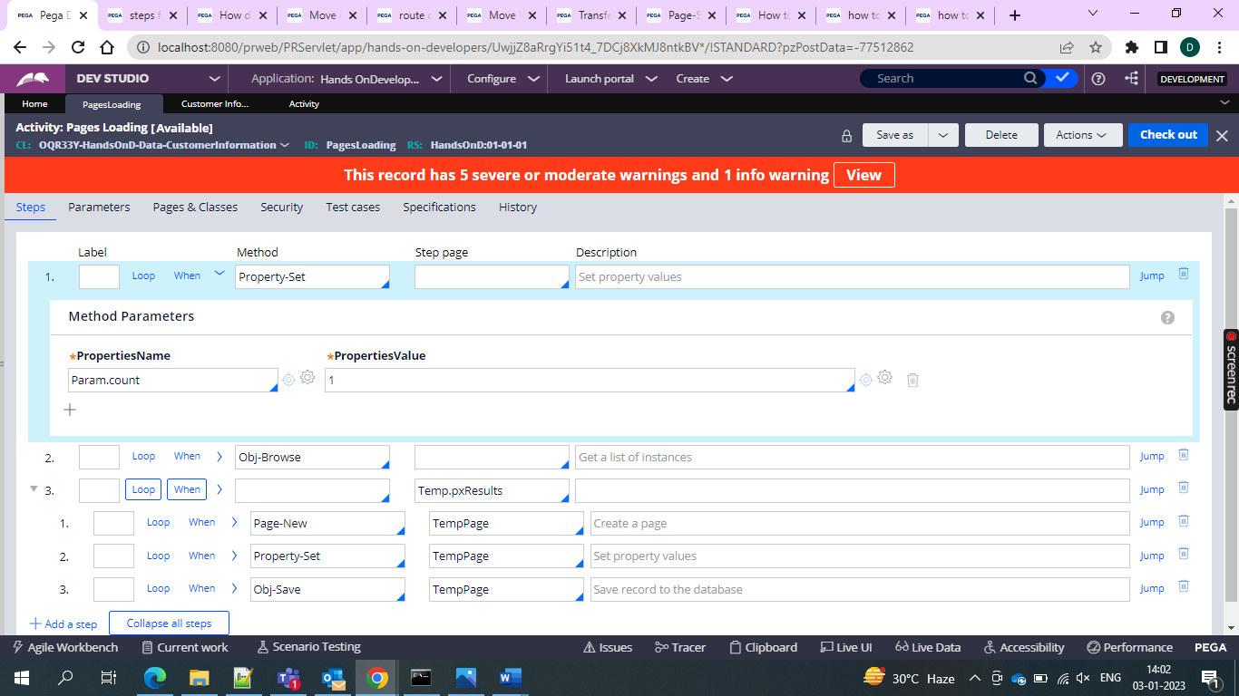

Then after setting count and then go for the Obj-Browse 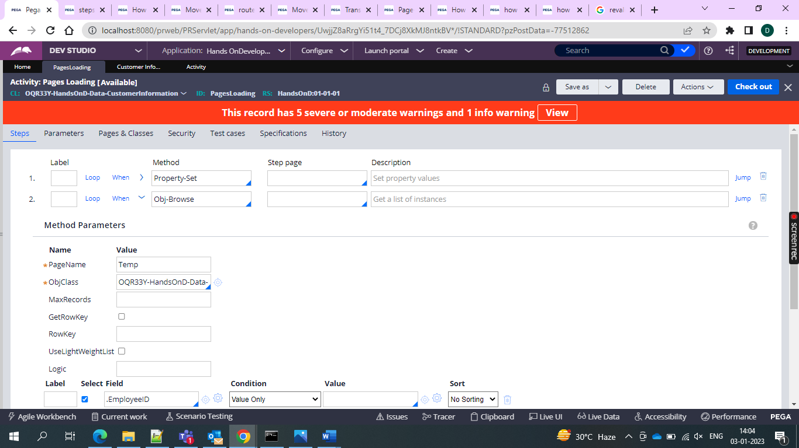

And then add the when condition to check for 5 records bewcuase I want 5 records if more than 5 exit iteration and loop on the page

Then take a new page and then set the property set and gfive the values which you want to see the results

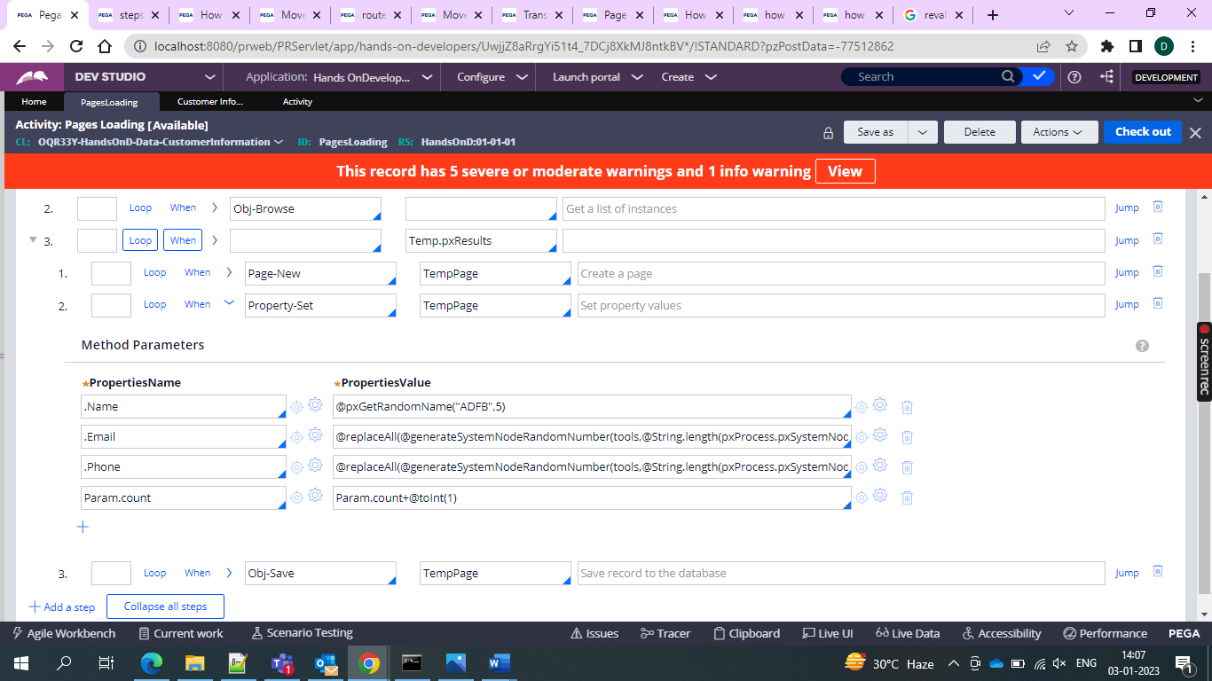

For random name

@pxGetRandomName("ADFB",5)

For email

@replaceAll(@generateSystemNodeRandomNumber(tools,@String.length(pxProcess.pxSystemNodeID)+10),pxProcess.pxSystemNodeID,[")+"@gmail.com](mailto:%22)+%22@gmail.com)

And then for number

replaceAll(generateSystemNodeRandomNumber(tools,@String.length(pxProcess.pxSystemNodeID)+10),pxProcess.pxSystemNodeID,"")

and then do a obj-save

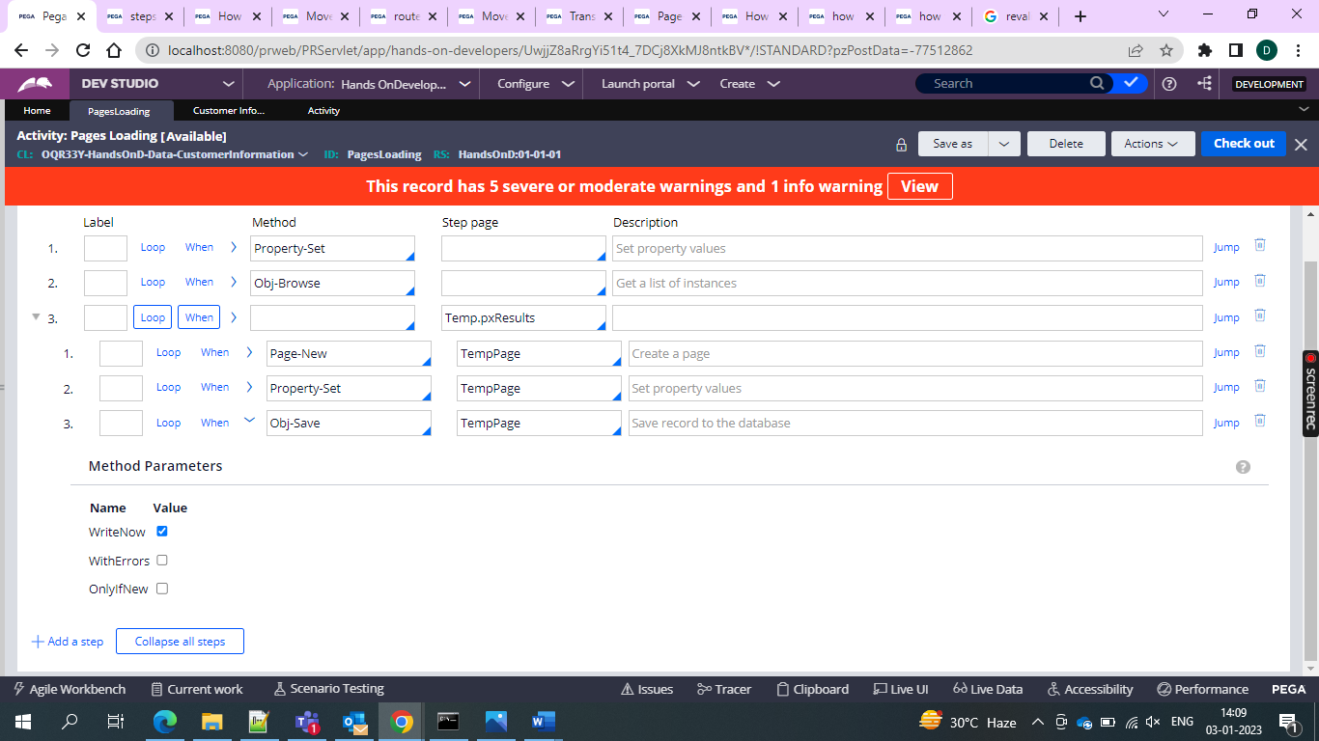

And then run the activity and records would be shown

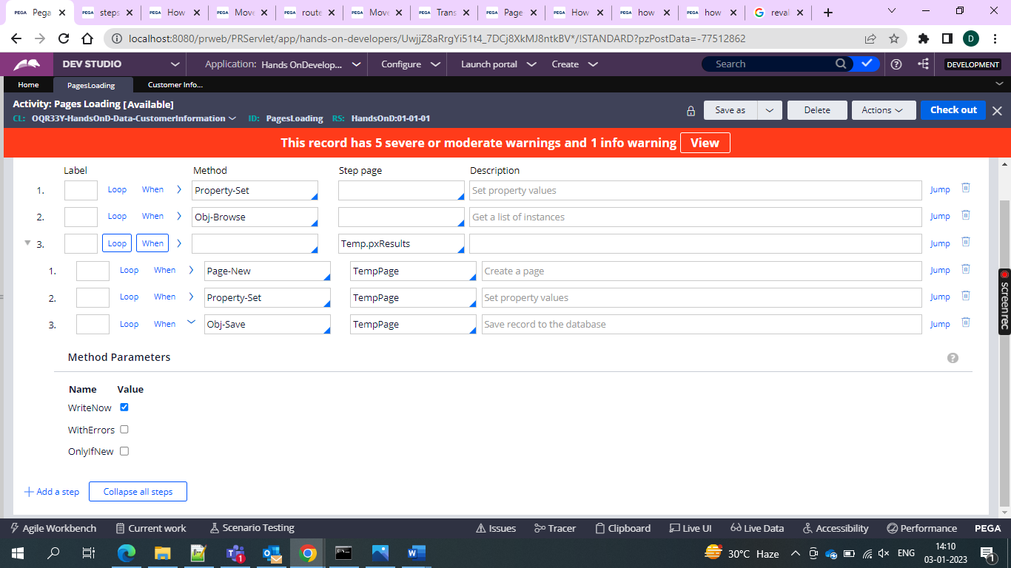

And then we can get the records in the datatable

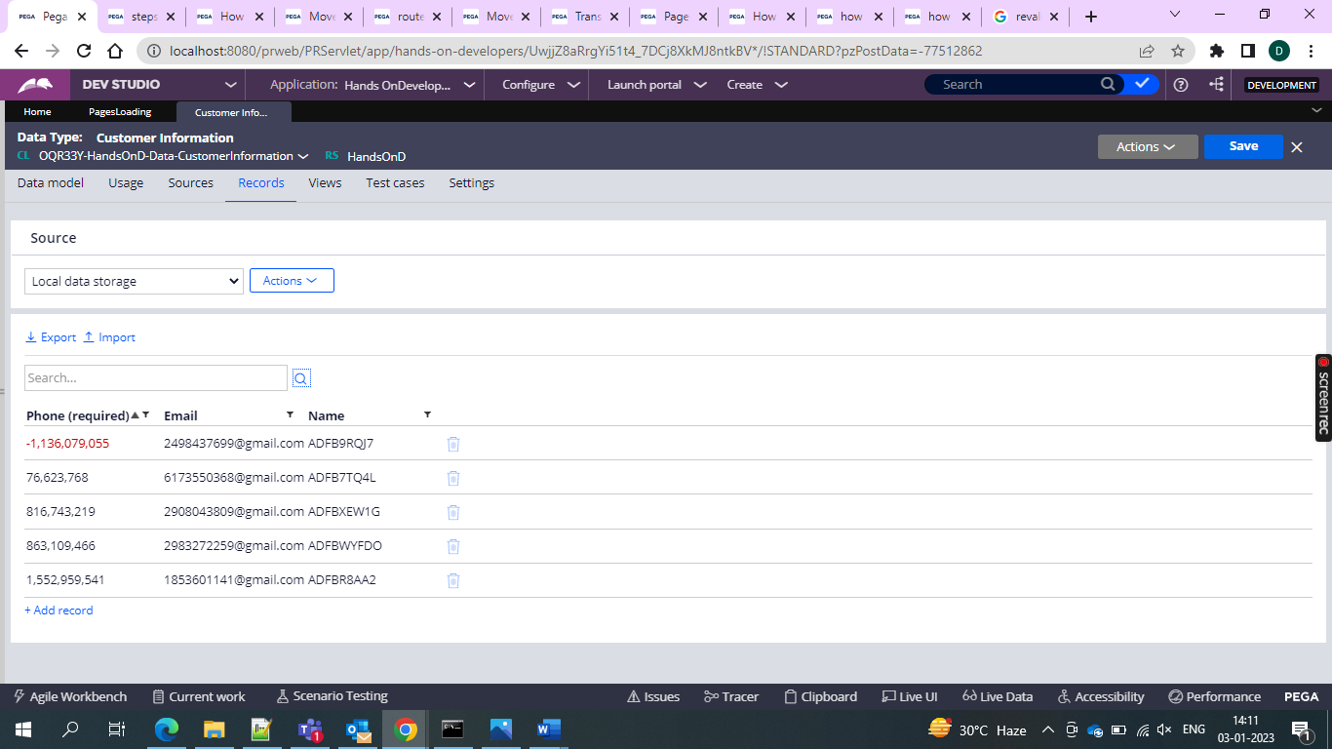

So by this we can get the results of the 5 and can use them in pagelist